Explain Idea logic

Design Pattern:

1. MVC

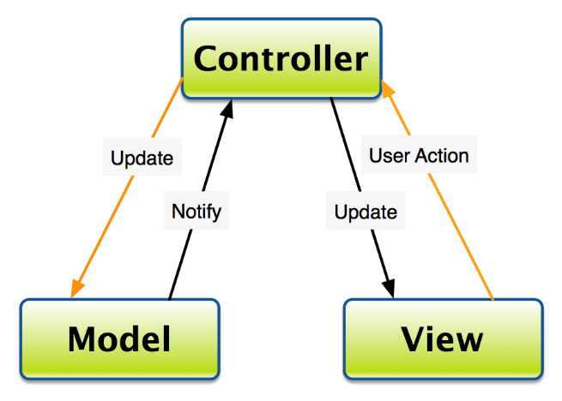

1. singleton pattern: The singleton pattern is a software design pattern that ensures a class has only one instance. It's a creational pattern, which means it's a set of rules for creating objects.

1. strategy pattern: **Strategy** is a behavioural design pattern that lets you define a family of algorithms, put each of them into a separate class, and make their objects interchangeable.

View:

Model:

Controller:

Main.java

startgame